# TITLE IS WRITTEN IN CAPITAL

# USE FONT ROBOTO 18 BOLD

**Authors [Constantia 11 with Bold]**

Name of Faculty or Program Study, Name of University (Authors Affiliates)

*Email author correspondent: author_@xxxx.com

**Abstract** **[****Constantia 11 with Bold in English]**

**Purpose –** Explain the purpose of the research briefly. [Constantia 10 in English]

**Method –** Explain the research method briefly. [Constantia 10 in English]

**Result –** Explain the research results briefly. [Constantia 10 in English]

**Implication –** Briefly describe research conclusions important to policy, practice, or theory. [Constantia 10 in English]

**Originality –** Explain the uniqueness or novelty of the research briefly. [Constantia 10 in English]

**The Originality** section is **optional**, so if this research is not unique or new compared to other studies, it does not need to be filled in and deleted.

**Keywords:** At least 4 keywords separated by a semicolon. [Constantia 10 single space]

## INTRODUCTION [Constantia, 12 bold]

The introduction encompasses the background of the research issue or problem and why the research is essential. This section includes a literature review that serves as the foundation for the research concept. The literature review is not limited to theory alone but includes empirical evidence. If applicable, the research hypothesis should be built upon theoretical concepts and supported by empirical studies (previous research). [Constantia, 12, normal].

## **RESEARCH METHOD** [Constantia, 12, Bold)

The research method explains the design of activities, scope or object, materials and primary tools, location, data collection techniques, operational definitions of research variables, and analysis techniques. [Constantia, 12, normal].

## RESULTS AND DISCUSSION [Constantia, 12, Bold]

This section presents the research findings. The research results may be supplemented with tables, graphs (images), and/or charts. The discussion section outlines the data processing results, interprets the findings logically, and relates them to relevant reference sources. [Constantia, 12, normal].

## REFERENCES [Constantia, 12, Bold)

The writing of the manuscript and the citations referred to in this manuscript are recommended to be done using reference management applications such as Mendeley, Zotero, RefWorks, EndNote, and others. Citations in the manuscript and the bibliography list follow the APA 6th edition guidelines. [Constantia, 12, Normal].

## CONCLUSION [Constantia, 12, Bold]

This section provides a summary of the research findings, the discussion, research limitations, and suggestions for further research. [Constantia, 12, Normal]

## ADDITIONAL INFORMATION

Tables are created with sequential numbers. The table title is placed above the table, and the image title is below the images. Horizontal lines in tables are only allowed in column headers and at the end of the column without using vertical lines. Below are the guidelines for creating tables.

**Table 1.** The number of research respondents. **[Constantia, 11, Bold Except** for the table name.**]**

|  |  |  |  |  |  |  |
| --- | --- | --- | --- | --- | --- | --- |
| No | Higher Education Institution [Constantia, 10, List Table 6 Colorful] | Distributed Questionnaire | Unreturned Questionnaires | Incomplete Questionnaires | | Questionnaires ready for processing |
| 1 | Tanjungpura University | 60 | 10 | 7 | | 43 |
| 2 | State Polytechnic of Pontianak | 20 | 0 | 0 | | 20 |
| 3 | Muhammadiyah University of Pontianak | 20 | 0 | 2 | | 18 |
| 4 | Panca Bhakti University | 20 | 3 | 5 | | 12 |
| Total | | 120 | 13 | 14 | 93 | |

Source: InVacation, 2023 [Constantia, 9]

Images are created in sequential order. The image title is placed below the image. Images are displayed clearly without blur. Here are the guidelines for creating images.

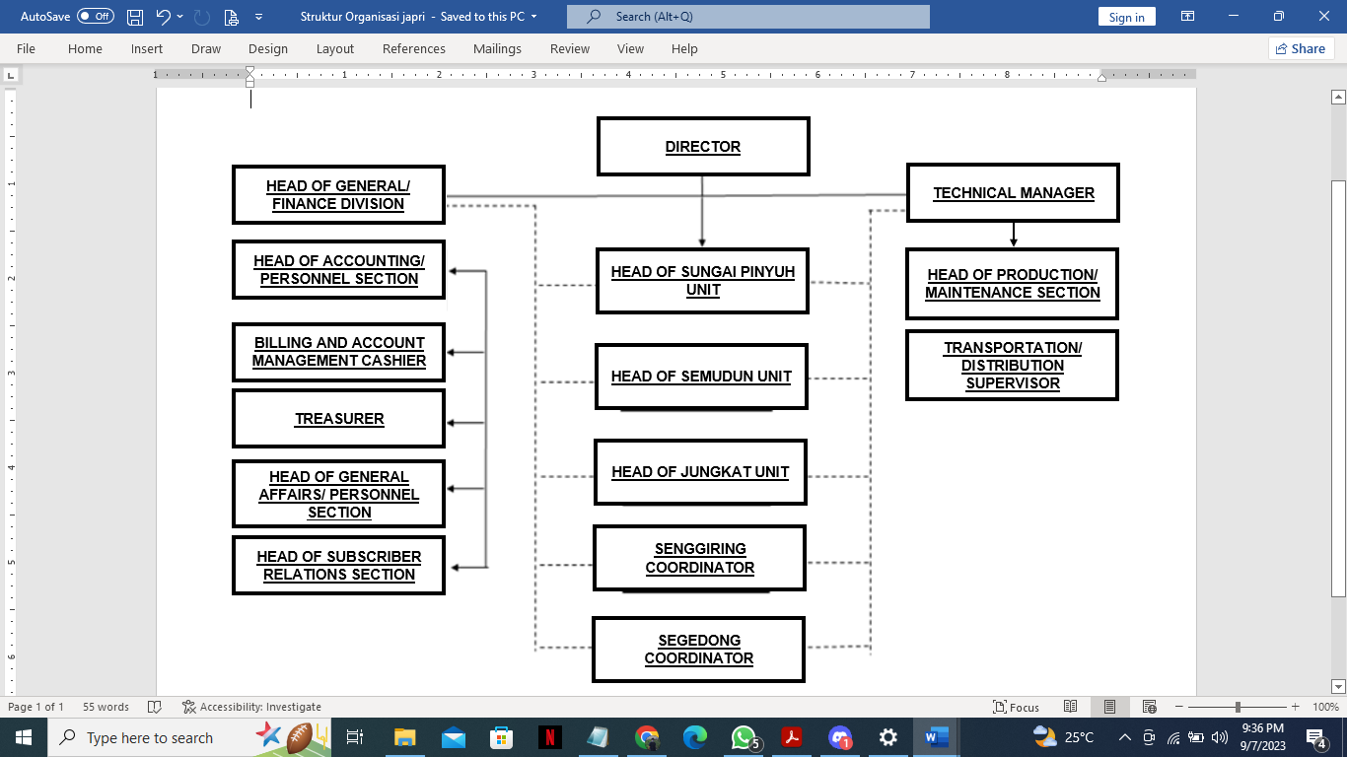Source: InVacation, 2023 [Constantia, 9]

**Images 1.** Organizational Structure **[Constantia, 11, Bold Except** for the table name**]**